Auxiliary Plaque of Merit
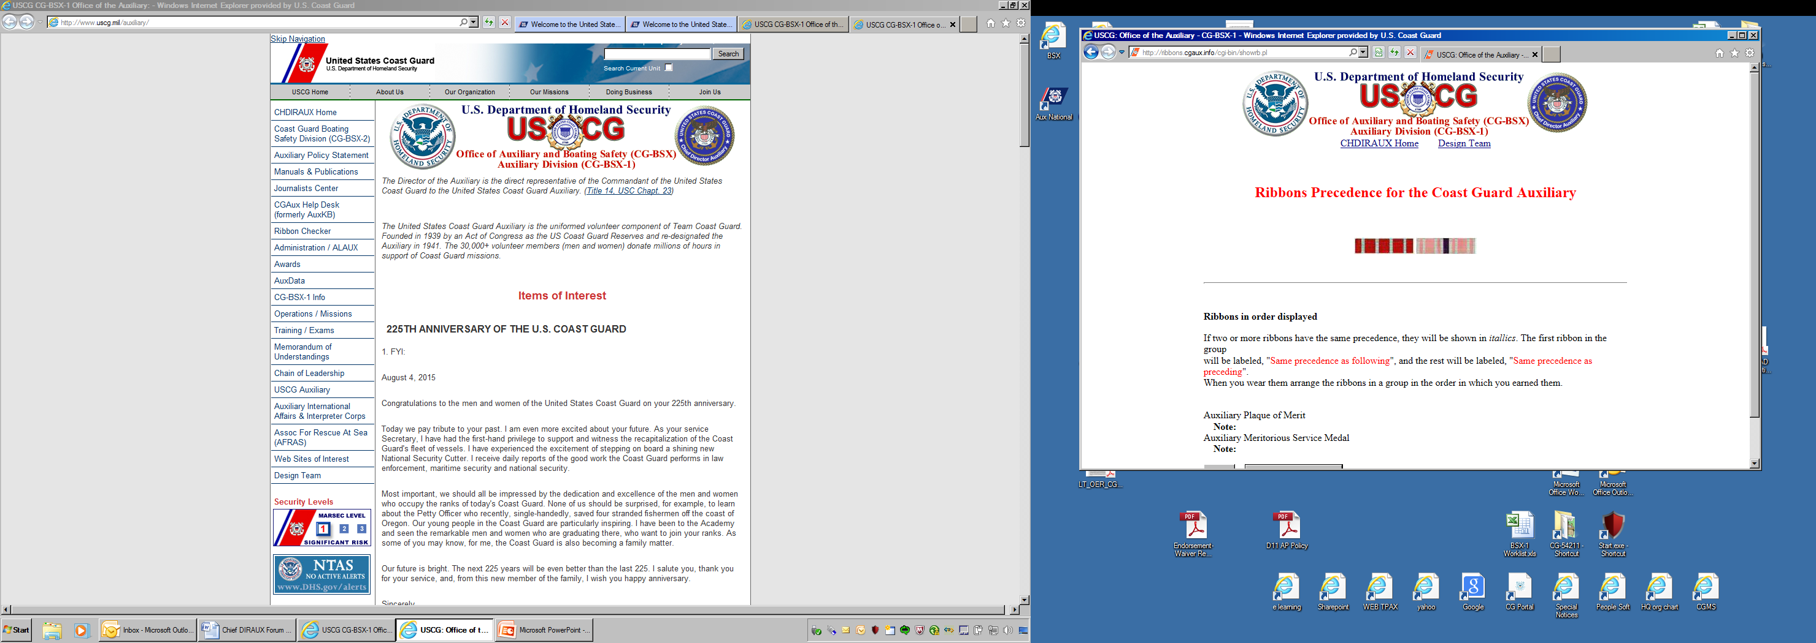

DATE: ___________

ORIGINATOR: ______________________________________

MEMBER’S NAME: ______________________________________

- Extreme skill in performing an assist or rescue at risk to the Auxiliarist’s life.

  - Can only be given for an assist or rescue (operational).

  - Heroism in the face of grave personal risk that clearly stands out as above normal expectations.

- Must be approved by a CG Flag Officer.

- Summary of Action or service must accompany Award Form and citation.

- Submit this form along with completed and signed D7 CG 1650 form and award citation.

- Are all spelling, grammar, punctuation, line count, type and point, and margins correct?

- Does the award citation meet the criteria required?

Routing Signatures:

Flotilla Commander ______________________ Division Commander _______________________

District Captain _______________________

District Directorate Chief _________________ District Chief of Staff_____________________

